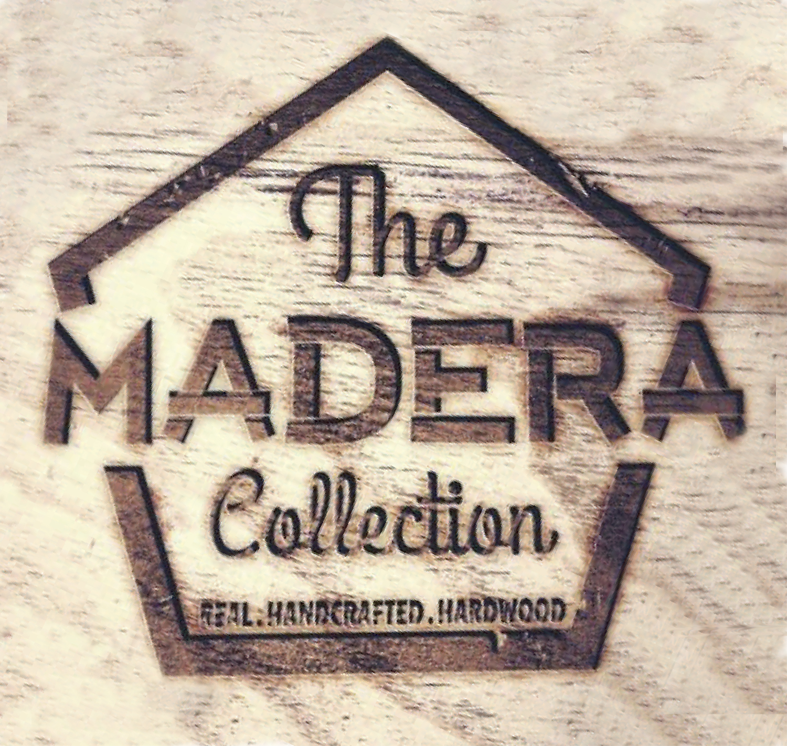

Warranty for Bluffs, Cavalier, Cliffs, and Plaza

Full 30 Residential Structural Warranty
All Madera Engineered Flooring is warranted in their original manufactured state, to be free from defects in lamination, assembly, milling, and grading for a full 30 Years, or as long as the original purchaser owns the home.
Full 30 Year Residential Finish Warranty

Madera Engineered Flooring is warranted to the original purchaser, that the finish will not wear through for the lesser of 30 full years or as long as the original purchaser owns the home, for all Madera aluminum-oxide finished products.

Limited 3 Year Light Commercial Warranty

A Light Commercial application is defined as use in non-industrial settings. The following areas have been approved for the on, above or below grade installation of Madera Engineered Flooring products:

- Condominiums
- Executive Office/Conference/Board Rooms
- Cafeteria/Dining (excluding Wet Areas)
- Doctor/Dental Offices
- Nursing Home Common Areas
- Lounge (excluding Service Areas)
- Classrooms
- Retail Sales Floors
- Hospitality Rooms

Note: Areas with heavy foot traffic, like airports and department store aisles or entrances, are not warranted.

About Warranty Coverage

Installations must be performed in accordance with all Madera Engineered Flooring Installation Instructions. Failure to install and maintain under the guidelines of these manufacturer’s instructions will void all warranties. It is the responsibility of the installer and/or end user of the material to inspect boards prior to installation. Madera Engineered Flooring accepts no responsibility for costs of product or labor when boards with visible defects have been installed. Once installed, the flooring has been deemed acceptable by the installer.

Wood color, tone, and graining variations in flooring are a natural occurrence due to species, age, character of flooring and exposure to UV light or sunlight. For these reasons, new and/or replacement flooring may not match display samples and/or existing flooring.
Madera Engineered Flooring is not responsible for color variation of product and/or samples for the consumer matching flooring to other wood products, such as cabinets, stair railings, trim and moldings. Naturally occurring wood characteristics such as variations in grain, color, mineral streaks and knots, are not considered defects.
Normal exposure to sunlight will bring about changes in the shading of any hardwood floor as the floor ages. Area rugs should be moved occasionally as they block sunlight and may give the appearance of discoloring under the rug. This is not a product defect.
The sole obligation and liability of Madera Engineered Flooring, under our stated warranties, is to repair, replace or refinish the floor, in part, or in whole the original product that failed to comply with the applicable warranty. Madera Engineered Flooring shall retain sole authority to select the best means possible to satisfy the original purchaser.
Under the terms of these limited warranties, Madera Engineered Flooring will not be liable for indirect, special, incidental, consequential or other cost, expenses or damages of any kind to the purchaser, no matter what the cause. A Madera Engineered Flooring representative has the right to inspect any warranty claim. Madera Engineered Flooring will not process any warranty claim on product that has been removed after installation, prior to an inspection by a representative. It is critical that all installations are done in compliance with all installation instructions.
Warranty Disclaimers and Exclusions
Madera Engineered Flooring warranties do not cover indentations, scratches, stains or damage caused by negligence, fire, water, moisture, excessive heat or excessive dryness, erosion, pebbles, sand or other abrasives, pets, insects, spiked heel shoes, color variations, naturally occurring wood characteristics like knots and mineral streaks, failure to follow all the manufacturer’s written installation and/or maintenance instructions, improper maintenance, insufficient protection, misuse or improper alterations of the original manufactured product.

Madera Engineered Flooring warranties do not cover natural expansion and contraction resulting in separation between boards, or damage caused by low or excessive humidity. Faulty vapor barrier, plumbing leaks, floods, extreme weather conditions, or acts of God will void the warranties. Heating and ventilating must provide a controlled environment to maintain relative humidity between 35%-55%. Moisture emission of concrete must not exceed 3.0lbs per CaCl test method. Maximum moisture content of wood subfloor must not exceed 12% using a pin type moisture meter.

No warranties apply to any product(s) designated as thrift, antique, tavern, bargain or cabin grades, seconds, economy grade, drops or non-standard items. Any product(s) so designated are sold “as is”.

This writing is the complete and exclusive statement of the express warranties provided herein and is in lieu of all other express and/or statutory warranties by the manufacturer, to the extent provided by Texas State law. Madera Engineered Flooring assumes no liability for incidental or consequential damages. However, some states do not allow the exclusion or limitation of incidental or consequential damages, so this exclusion may not apply to you. This warranty gives you the specific legal rights, and you may also have other rights that vary from state to state. The sole remedy provided herein is the repair, refinish or replacement of defective products, or refund for defective products.

